**DOUBLE YOUR TRAVEL EXPERIENCE DISCOVERING ARMENIA AND GEORGIA**

Travel to the **Routes of Civilization** to get in touch with great **heritage** and the array of **culture** that **Biblical country Armenia** offers as a travel destination. Experience **genuine interaction with people** and create amazing memories, encounter with **authentic, diverse and delicious cuisine and** spoil your taste buds with **legendary Armenian cognac and wine**.

During this tour you will pass through **millennia long history**, culture and culinary traditions up to nowadays modern Armenia and its “Pink City” capital Yerevan: **history before and after the Christ on the Holy Land**, where Christianity was officially adopted in 301 A.D as a first state religion in the world and where **Noah arrived** once upon a time.

**Georgia (Sakartvelo)-** a magical country that year after year attracts tourists more and more with its **hospitality** and an abundance of interesting excursions. **Georgian cuisine** will not leave anyone indifferent. **Master classes** of Georgian cuisine will give you the opportunity to experience the whole life and essence of the Georgian people - **Khinkali, Khachapuri, Mtsvadi, Churchkhela. This is Georgia!**

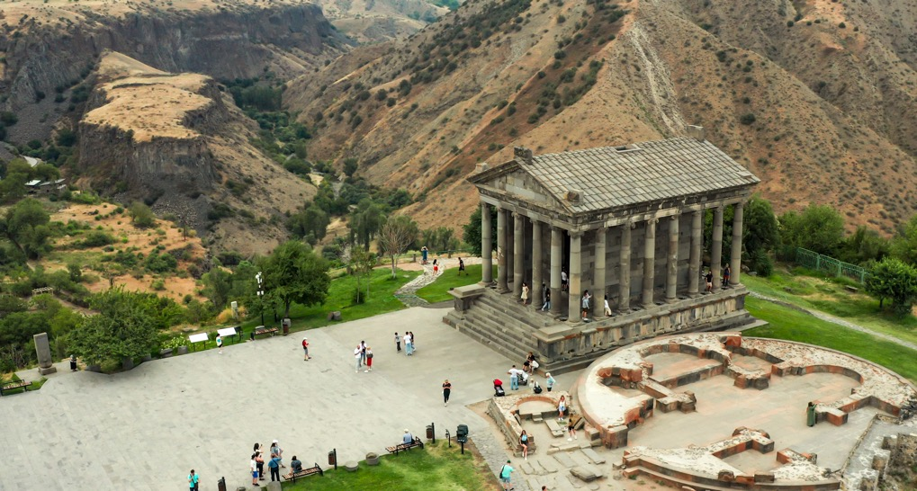 **DESTINATION: ARMENIA - GEORGIA**

**DATES: 1 MARCH-31 OCTOBER (HIGH SEASON)**

**1 NOVEMBER-28 FEBRUARY (LOW SEASON)**

**\*\*\* FROM 25 DECEMBER TILL 06 JANUARY-HIGH SEASON RATES**

**GROUP SIZE: MIN. 2PAX; MAX. 9PAX**

**TRIP DURATION: 4DAYS & 3NIGHTS**

**Itinerary**

**Day 1: Arrival to Yerevan, UNESCO World Heritage Site Geghard Monastery, Garni Pagan Temple, NOY Brandy-Wine-Vodka Factory**

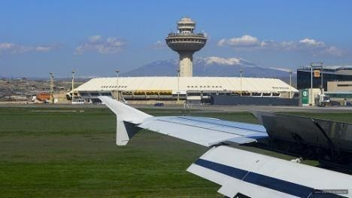 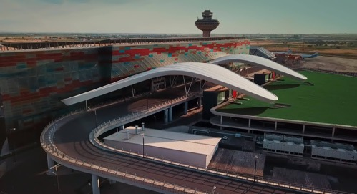

**11:20 /** Welcome to **Yerevan**, the capital city of **Armenia**. Our tour leader will greet you at the airport and help you with all the ground handling services.

**13:30-14:30** / Lunch will be in a cozy Armenian restaurant with a panoramic view to Temple Garni. Here you will participate in a traditional Armenian lavash baking preparation master class․

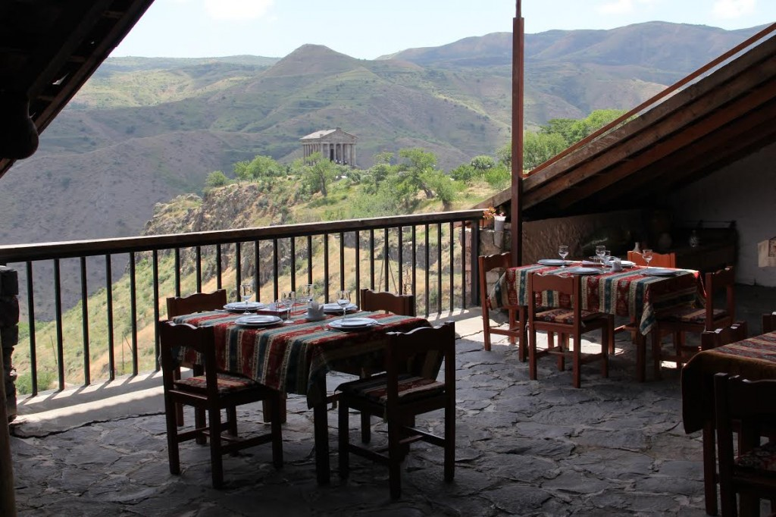 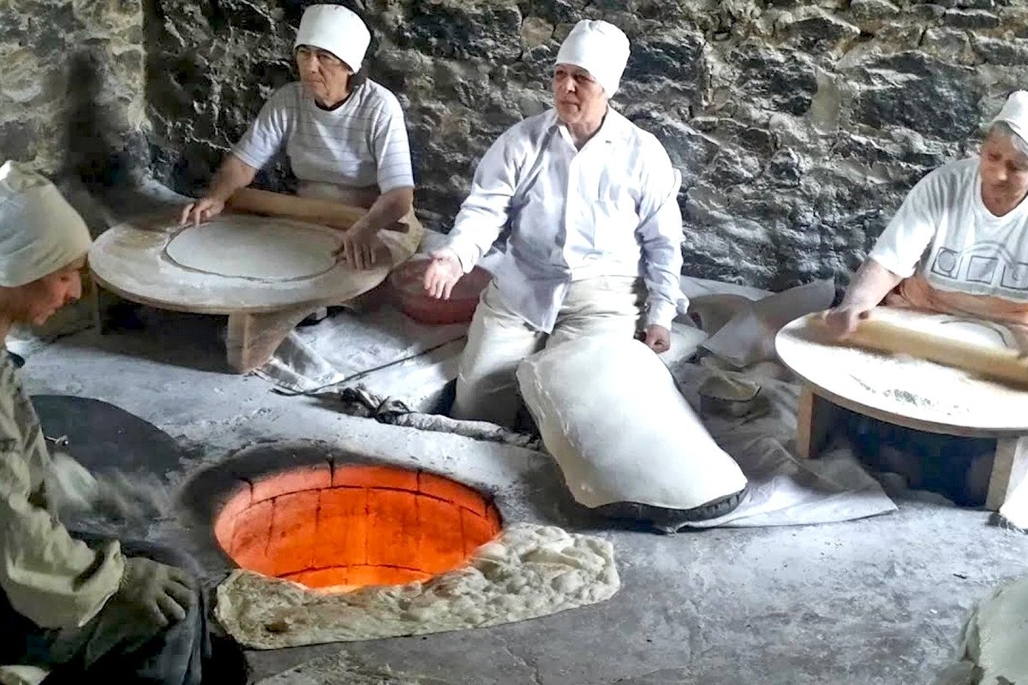 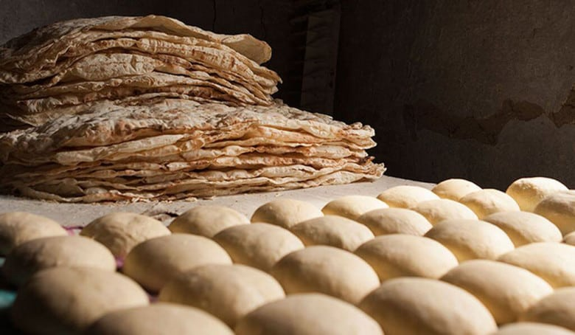

**14:30-15:30 /** We continue towards **Garni Temple** - the only standing Greco-Roman colonnaded Pagan temple in Armenia and the former Soviet Union. An Ionic pagan temple located in the village of Garni is the best-known structure and symbol of Pre-Christian Armenia. The structure was built in the 1st century AD as a temple to the God of Sun.

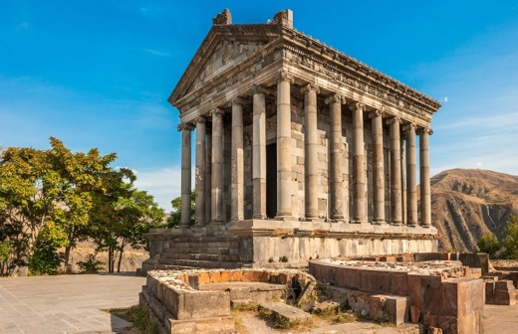 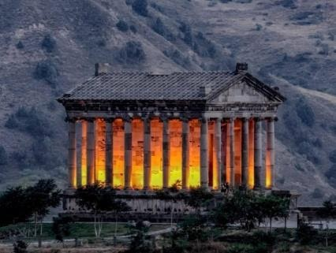

**15:45-16:30 /** Barely recovered from the musical and cultural strong impressions, we take you to **Symphony of Stones** (half of the road to the Symphony of Stones is hiking) where you can listen to the silent music of stones, that the virtuoso nature has created himself. **Garni gorge** is one of the most exceptional places for tourists to visit and to see amazing natural rocks known as the **“Symphony of Stones” or “Basalt organ”.** The rocks have a shape of long hexagonal vertical columns, which are associated with the church organ. Huge stone pillars are located at an altitude of about 50 meters above the ground. It’s hard to believe that neatly and symmetrically sculpted stones are created by nature itself and not by human.

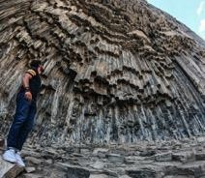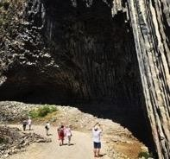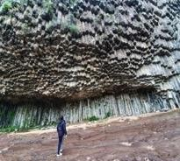

**16:50-18:00 /** Our next stop is at **Geghard Monastery** - an incredible medieval monastery, being partially carved out of the adjacent mountain, surrounded by cliffs. It is listed as a UNESCO World Heritage Site with enhanced protection status. Here you may have a chance to enjoy the performance of a fantastic choir in one of the chambers of the monastery with one of the greatest acoustics you have ever seen. The choir will leave you with goose bumps and unforgettable emotions.

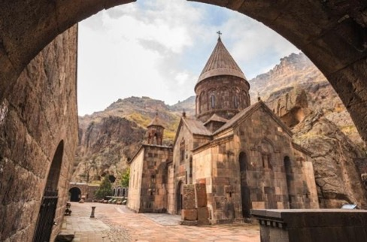 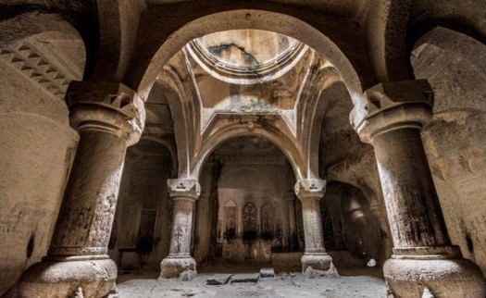

**19:00** / Back to Yerevan. The rest of the day is free.

**Accommodation**

* Overnight in Yerevan at Ani Central Inn 4*, Ani Grand Hotel 4*, Ramada Hotel 4* or BWP Congress Hotel 4* on BB/DBL room sharing basis.  Single supplement is available at extra cost.

**Included Activities**

* Garni Pagan Temple
* Lavash Baking Master Class
* Symphony of Stones
* Geghard Monastery

**Meals Included**

* Breakfast at the hotel

**Day 2: Vernissage, Sevan Lake, Sevanavank Monastery, Dilijan, UNESCO World Heritage Site Haghpat Monastery, Bagratashen Checkpoint**

**08:00 - Breakfast in the hotel and check out**

**09:00 – Starting the tour**

**09:00 – 10:30 /** Don’t forget to grab some souvenirs and gifts for beloved ones from Armenia! We will visit **Vernissage** for souvenirs. Yerevan’s Flea Market is probably one of the best open-air markets in the world. It is called Vernissage (varnishing, from French) — a term used for a preview of an art exhibition. A visit to the market will make the day more beautiful. It offers various kinds of nice national souvenirs, jewelry and other traditional items. The Vernissage is the right place to get little taste of Armenia and a special spot to witness the fusion between national traditions and modern taste.

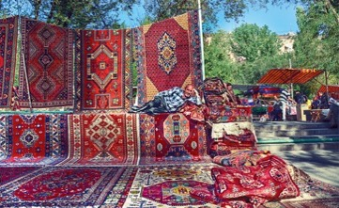 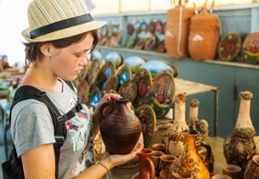 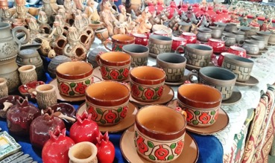

**11:30 – 12:30 /** Not a single visit to Armenia is complete without visiting her majesty**Lake****Sevan** - the highest freshwater mountain lake in Europe, and surrounded by the Lesser Caucasus Mountain range. Set 1900m above sea level, Sevan is the largest lake in the Caucasus, it's also one of the largest freshwater high-altitude lakes in the world. Its colors and shades change with the weather and by its own mysterious processes, from a dazzling azure to dark blue and a thousand shades in between.

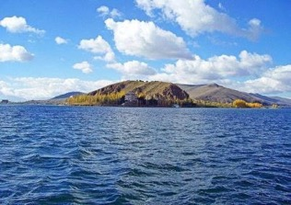 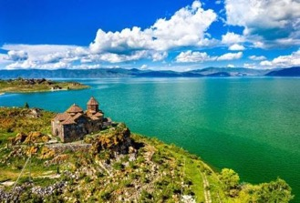 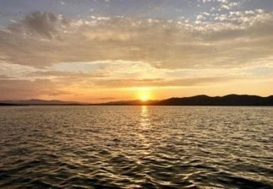

**Sevanavank Monastery** Enjoy a visit to the picturesque site of monastery, an ancient religious complex that overlooks Lake Sevan. Situated on a peninsula that was once an island before the water level dropped, the monastery stands atop a hill, with scenic views of the lake and the often-snow-capped slopes in the backdrop. You'll need to climb a number of stairs to reach the site, but you'll be rewarded with inspiring panoramic views. Explore the two historic churches, most likely dating from the 9th century and exhibiting a typical, simple Armenian style of architecture.

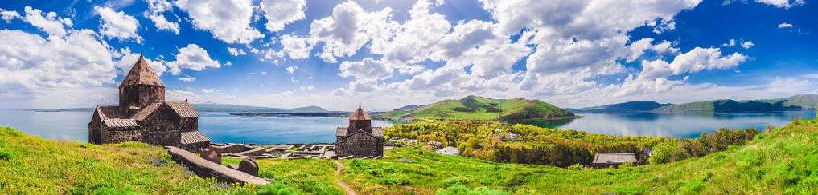

**13:00 – 13:30 /** After our day continues to beautiful city of **Dilijan** that is sometimes referred to as the forest kingdom of Armenia. In this cozy town, you can find vivid examples of traditional wooden house architecture. The mountains and gorges are covered with rich forests changing to alpine meadows and dotted with small farms, hiking tracks, lakes and rivers. The mountainous landscape is highly diverse, with different terrains, climates, soils and water resources. Many natural and man-made features enrich the national park: monasteries, lakes, archeological sites, forests, rivers and farmland create an endlessly-changing environment.

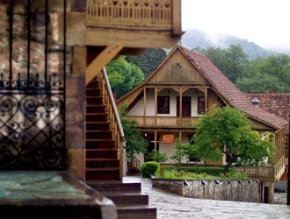 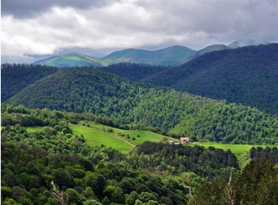 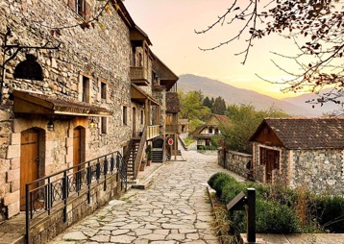

**13:30 – 14:30 /** Lunch will be at **Toon Armeni restaurant.**

**16:30 – 17:20 /** Our next stop is **Haghpat Monastery.** The monastic complex is included in **UNESCO World Heritage list.** It represents the highest flowering of Armenian religious architecture of that era.  The functional role, location and stylistic characteristics were taken into consideration during the construction of the building that stands in perfect harmony with the picturesque landscape.

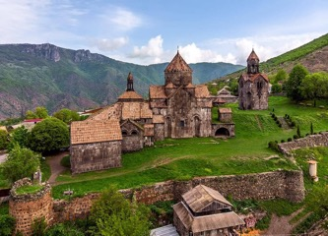 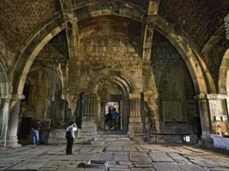 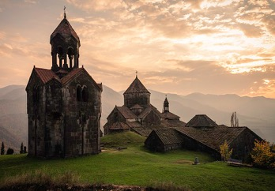

**18:00 /** We will reach **Bagratashen checkpoint**, from where the Georgian side will welcome you and the tour will continue in Georgia.

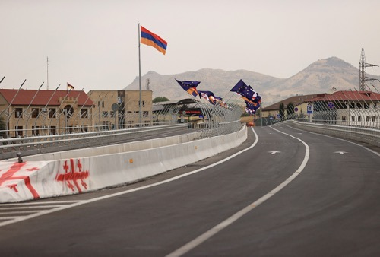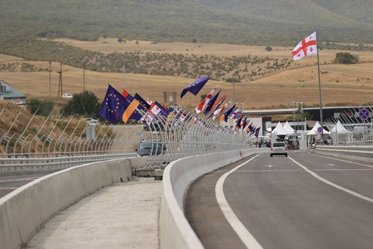

**Accommodation**

##### Overnight in Tbilisi at Brim Hotel 3*, Holiday Inn Express Tbilisi Avlabari 3*, Hotel Golden Tulip Design Tbilisi 4*, or Museum Hotel 4* on BB/DBL room sharing basis. Single supplement is available at extra cost.

**Included Activities**

* Vernissage
* Lake Sevan
* Sevanavank Monastery
* Dilijan
* UNESCO World Heritage Site Haghpat Monastery

**Meals Included**

* Breakfast at the hotel

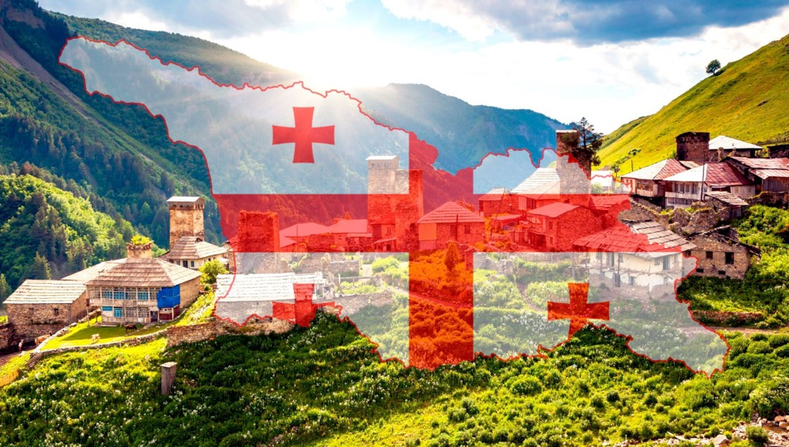

***Welcome to SAKARTVELO***

**19:30 /** Dinner in Georgia at Georgian Restaurant

**22.00 /** Check in at the hotel

**Day 3: Tbilisi City Tour, Mtskheta**

**08:00 – Breakfast in the hotel**

**09:00 - Starting the tour**

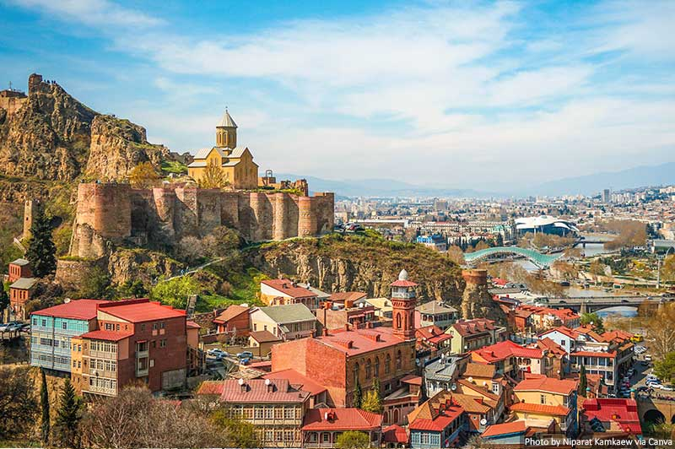**Old Town Tbilisi**

We will continue our tour to old part of Tbilisi where you will visit fallowing places: - Tbilisi Sulphur pools - Bridge of Love - Waterfall - Meidan Bazar Tunnel - Gorgasali Monument - Mother of Georgia - Bridge of Peace - Tbilisi clock tower - Anchiskhati - Monument of Tamada - Shardeni Street. Will also drive through main streets and pass: - Freedom square - Rustaveli avenue - Hero square - Agmashenebeli Avenue - President House.

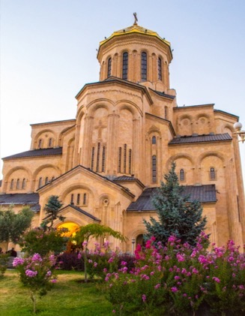

**Sameba**

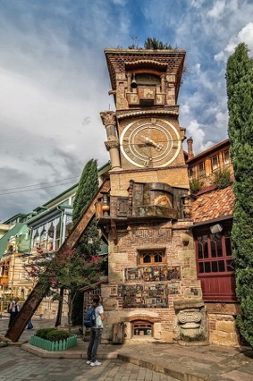Our first stop is Holy Trinity Cathedral, locally known as “Sameba.” The Cathedral construction was only completed in 2004, so it doesn’t offer the same history as most other Tbilisi churches. But the Holy Trinity Cathedral is impressive in different ways. It’s the third-largest Orthodox cathedral globally, with 97.5 meters only after the Saint Isaac´s Cathedral in Saint Petersburg and the Cathedral of Christ the Savior in Moscow.

**Rezo Gabriadze clock**

Then we will visit the famous Rezo Gabriadze clock. The clock tower was created by the renowned Georgian puppeteer Rezo Gabriadze. On the hour, a window opens at the top and an angel strikes the bell. Below the clock, a screen opens and shows the circle of life: boy meets girl, marriage, childbirth and funeral. The Clock Tower is a popular tourist attraction in the Old Town.

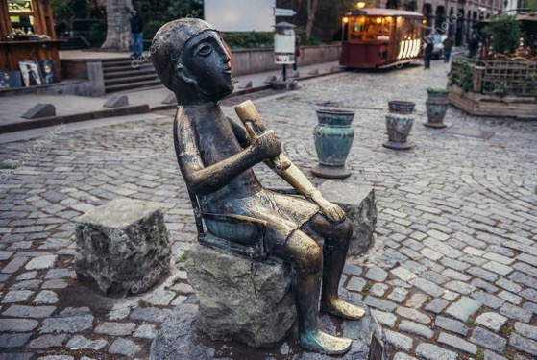

**Tamada (toaster)** is definitely a very good representation of Georgian traditions. Being a toaster in Georgia means being a very respected and important person at the table who is being in charge of “toasts”.

**14:00 /** We will have a lunch.

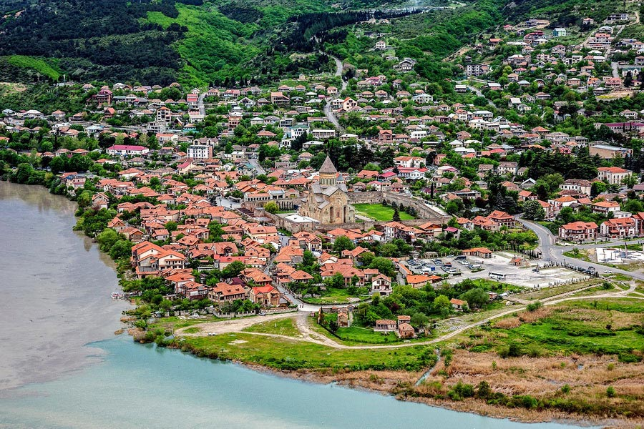**15:00 / Mtskheta**

Then discover the soul of Georgia through its ancient history and charming landscapes on our unforgettable tour to Mtskheta—the cradle of Georgian civilization and its first capital. Starting your Georgian adventure here is not just an option, it's a narrative of the country's rich history that resonates in every corner of this ancient city.

**18:30 /** Return to Hotel.

##### 20:30 / Dinner at Georgian Restaurant.

##### Accommodation

##### Overnight in Tbilisi at Brim Hotel 3*, Holiday Inn Express Tbilisi Avlabari 3*, Hotel Golden Tulip Design Tbilisi 4*, or Museum Hotel 4* on BB/DBL room sharing basis. Single supplement is available at extra cost.

##### Included Activities

* Tbilisi City Tour
* Mtskheta

##### Meals Included

* Breakfast at the Hotel

**Day 4: Departure**

**08:00 /** Breakfast at the Hotel and Check out

**09:00 /** Free time

**14:00 /** Departure to the airport

**See you soon.** We hope that while looking at Armenia and Georgia pinned in your travel map, will bring back unforgettable memories and experience during your trip with us!

## Included

* Accommodation on DBL room basis. Single room supplement is available at extra cost.
  + Total Hotels – 3 nights
* Meals – Breakfast
* Daily bottled water
* Transportation: 2, 3 PAX - Sedan / 4,5 PAX - Minivan / 6, 7, 8, 9 PAX - 17 seat sprinter
* WiFi on board
* Private Round-trip airport transfers
* All museum and entrance tickets according to the itinerary
* English speaking Tour Guide
* All taxes included

**Not Included**

* Air tickets (can be provided upon request)
* Travel Insurance (upon request)
* Alcoholic beverages in all meals
* Any meals that are not specified in the itinerary
* Personal expenses
* Tips (optional)

**Prices and Policies**

*** Rates are **NET** non-commissionable in **USD** and **per person**. Rates and rooms are subject to change and availability due to currency fluctuations, increased taxes, holidays and special events and other reasons, and will be confirmed at the time of final booking.

*** Child Policy & Rates: Each hotel has its own policy. Please check with us for the child policy for each hotel at the time of booking.

**HIGH SEASON PRICES (1 MARCH - 31 0OCTOBER)**

|  |  |  |  |  |  |  |  |  |  |
| --- | --- | --- | --- | --- | --- | --- | --- | --- | --- |
| **Hotels** | **2PAX/DBL** | **3 PAX/DBL** | **4 PAX/DBL** | **5 PAX/DBL** | **6 PAX/DBL** | **7 PAX/DBL** | **8 PAX/DBL** | **9 PAX/DBL** | **SGL Spl. at extra cost** |
| **Hotel Ani Central Inn Yerevan 4* / Brim Hotel 3*or Holiday Inn Express Tbilisi Avlabari 3\*** | $ 970 | $ 800 | $ 720 | $ 660 | $ 640 | $ 600 | $ 580 | $ 560 | + $ 170 |
| **Hotel Ani Grand Yerevan 4* / Brim Hotel 3*or Holiday Inn Express Tbilisi Avlabari 3\*** | $ 980 | $ 810 | $ 730 | $ 670 | $ 650 | $ 620 | $ 600 | $ 580 | + $ 180 |
| **Ramada Hotel Yerevan 5* / Brim Hotel 3*or Holiday Inn Express Tbilisi Avlabari 3\*** | $ 990 | $ 820 | $ 740 | $ 680 | $ 660 | $ 630 | $ 610 | $ 590 | + $ 180 |
| **BWP Congress Hotel Yerevan 4* / Brim Hotel 3*or Holiday Inn Express Tbilisi Avlabari 3\*** | $ 990 | $ 820 | $ 740 | $ 680 | $ 660 | $ 620 | $ 600 | $ 580 | + $ 170 |

|  |  |  |  |  |  |  |  |  |  |
| --- | --- | --- | --- | --- | --- | --- | --- | --- | --- |
| **Hotels** | **2PAX/DBL** | **3 PAX/DBL** | **4 PAX/DBL** | **5 PAX/DBL** | **6 PAX/DBL** | **7 PAX/DBL** | **8 PAX/DBL** | **9 PAX/DBL** | **SGL Spl. at extra cost** |
| **Hotel Ani Central Inn Yerevan 4* / Hotel Golden Tulip Design Tbilisi 4*, or Museum Hotel 4\*** | $ 1010 | $ 840 | $ 760 | $ 700 | $ 680 | $ 640 | $ 620 | $ 600 | + $ 200 |
| **Hotel Ani Grand Yerevan 4* / Hotel Golden Tulip Design Tbilisi 4*, or Museum Hotel 4\*** | $ 1020 | $ 850 | $ 770 | $ 710 | $ 690 | $ 660 | $ 640 | $ 620 | + $ 210 |
| **Ramada Hotel Yerevan 5* / Hotel Golden Tulip Design Tbilisi 4*, or Museum Hotel 4\*** | $ 1030 | $ 860 | $ 780 | $ 720 | $ 700 | $ 670 | $ 650 | $ 630 | + $ 210 |
| **BWP Congress Hotel Yerevan 4* / Hotel Golden Tulip Design Tbilisi 4*, or Museum Hotel 4\*** | $ 1030 | $ 860 | $ 780 | $ 720 | $ 700 | $ 660 | $ 640 | $ 620 | + $ 200 |

**LOW SEASON PRICES (1 NOVEMBER – 28 FEBRUARY)**

|  |  |  |  |  |  |  |  |  |  |
| --- | --- | --- | --- | --- | --- | --- | --- | --- | --- |
| **Hotels** | **2PAX/DBL** | **3 PAX/DBL** | **4 PAX/DBL** | **5 PAX/DBL** | **6 PAX/DBL** | **7 PAX/DBL** | **8 PAX/DBL** | **9 PAX/DBL** | **SGL Spl. at extra cost** |
| **Hotel Ani Central Inn Yerevan 4* / Brim Hotel 3*or Holiday Inn Express Tbilisi Avlabari 3\*** | $ 920 | $ 750 | $ 670 | $ 610 | $ 590 | $ 560 | $ 540 | $ 520 | + $ 130 |
| **Hotel Ani Grand Yerevan 4* / Brim Hotel 3*or Holiday Inn Express Tbilisi Avlabari 3\*** | $ 930 | $ 750 | $ 680 | $ 620 | $ 590 | $ 570 | $ 550 | $ 530 | + $ 130 |
| **Ramada Hotel Yerevan 5* / Brim Hotel 3*or Holiday Inn Express Tbilisi Avlabari 3\*** | $ 930 | $ 760 | $ 680 | $ 620 | $ 600 | $ 580 | $ 560 | $ 540 | + $ 140 |
| **BWP Congress Hotel Yerevan 4* / Brim Hotel 3*or Holiday Inn Express Tbilisi Avlabari 3\*** | $ 930 | $ 760 | $ 680 | $ 620 | $ 600 | $ 570 | $ 550 | $ 530 | + $ 130 |

|  |  |  |  |  |  |  |  |  |  |
| --- | --- | --- | --- | --- | --- | --- | --- | --- | --- |
| **Hotels** | **2PAX/DBL** | **3 PAX/DBL** | **4 PAX/DBL** | **5 PAX/DBL** | **6 PAX/DBL** | **7 PAX/DBL** | **8 PAX/DBL** | **9 PAX/DBL** | **SGL Spl. at extra cost** |
| **Hotel Ani Central Inn Yerevan 4* / Hotel Golden Tulip Design Tbilisi 4*, or Museum Hotel 4\*** | $ 940 | $ 770 | $ 690 | $ 630 | $ 610 | $ 580 | $ 560 | $ 540 | + $ 150 |
| **Hotel Ani Grand Yerevan 4* / Hotel Golden Tulip Design Tbilisi 4*, or Museum Hotel 4\*** | $ 950 | $ 770 | $ 700 | $ 640 | $ 610 | $ 590 | $ 570 | $ 550 | + $ 150 |
| **Ramada Hotel Yerevan 5* / Hotel Golden Tulip Design Tbilisi 4*, or Museum Hotel 4\*** | $ 950 | $ 780 | $ 700 | $ 640 | $ 620 | $ 600 | $ 580 | $ 560 | + $ 160 |
| **BWP Congress Hotel Yerevan 4* / Hotel Golden Tulip Design Tbilisi 4*, or Museum Hotel 4\*** | $ 950 | $ 780 | $ 700 | $ 640 | $ 620 | $ 590 | $ 570 | $ 550 | + $ 150 |

**Travel Enjoy Respect…**